**Unit 10: Business report writing**



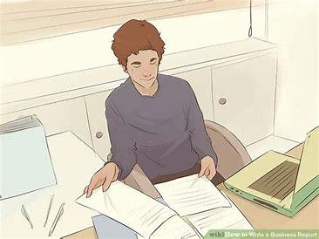

**Starter: Work in group of 3 and discuss the following questions. (15mns)**

1. Have you ever read a report before? Any report? Did you remember what it was about?
2. Have you ever written once on your own? Why? Or why not? If yes, what was it about?
3. What do you think is a good characteristic of a good report writing?
4. Why do we need to write a report?

**Activity 1: Match each report with its correct title. (10mns)** 

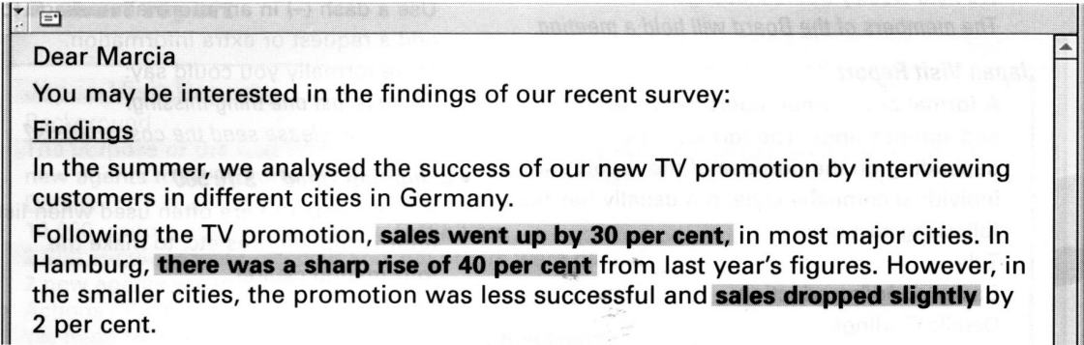



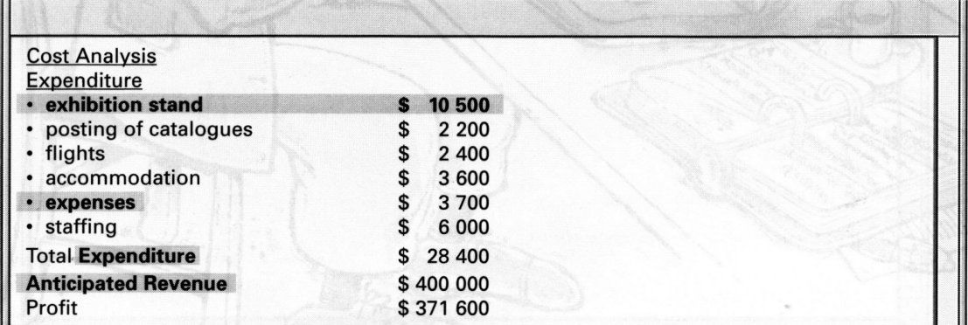



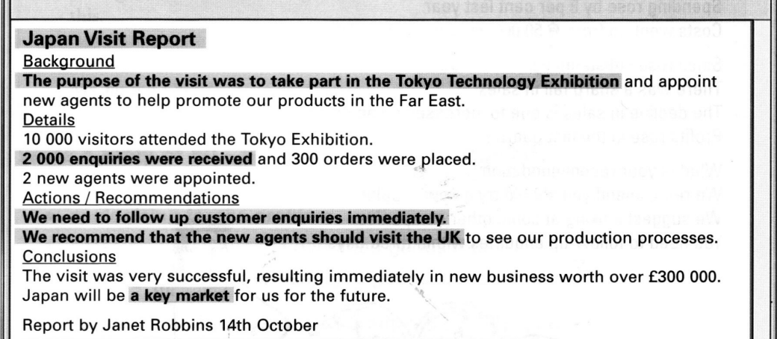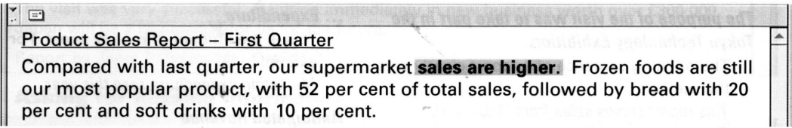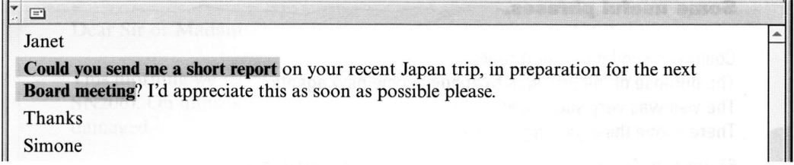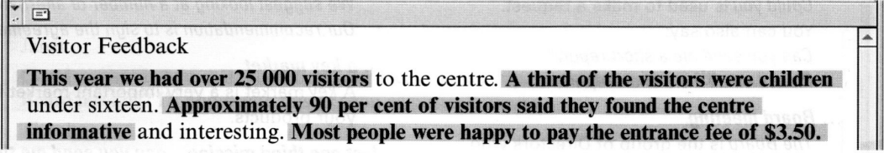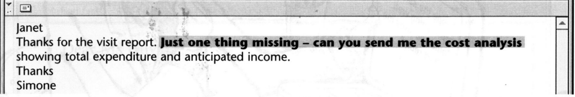

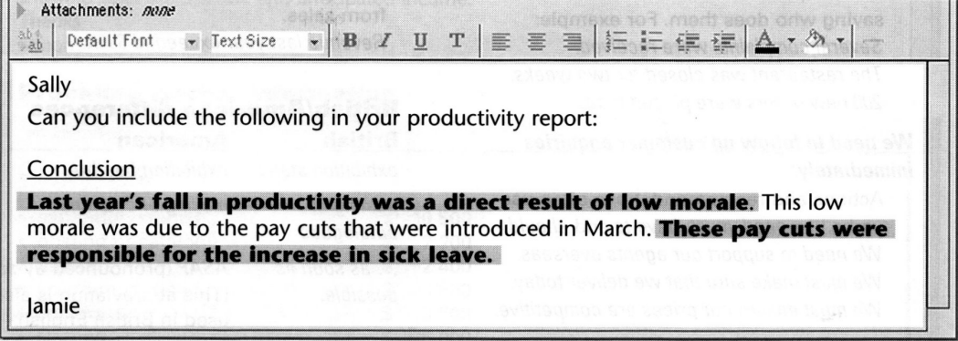



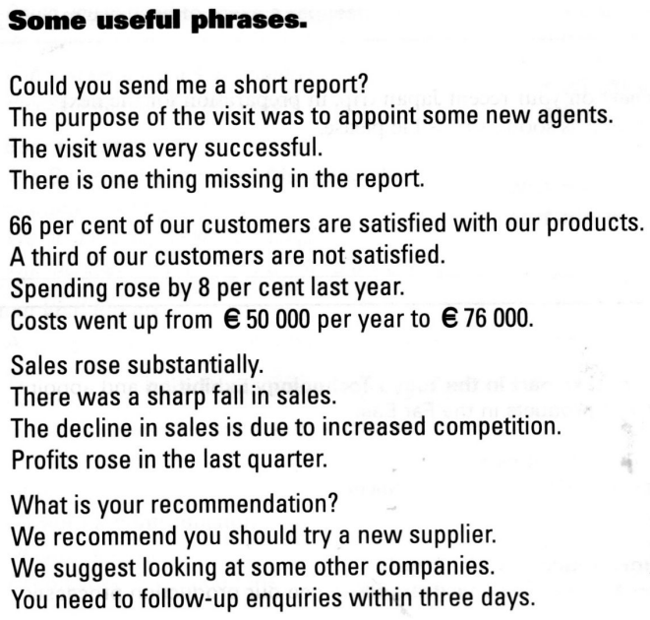



**Activity 2: Look at the company sale report below. Decide in which part of the report (A – D)**

**You would find the information (1 – 7). (15mns)**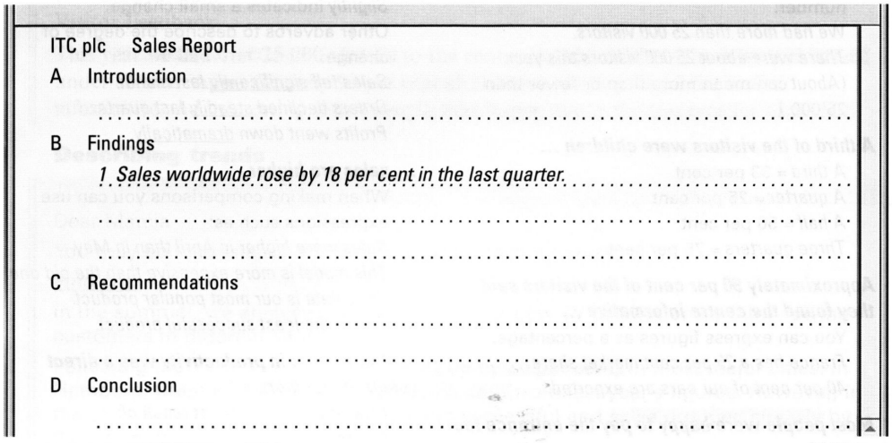

| **1** | **Sales worldwide rose by 18 per cent in the last quarter.** |
| --- | --- |
| **2** | **This report shows the breakdown of sales during the last year.** |
| **3** | **Europe still has the largest share of the market.** |
| **4** | **We need to increase our advertising in the Far East.** |
| **5** | **Overall, business was very good last year and we expect this success to continue.** |
| **6** | **Sales in the Far East fell by 3 per cent.** |
| **7** | **We must appoint new agents in the Far East.** |

**Activity 3: Underline the correct word to complete this report. (10mns)**

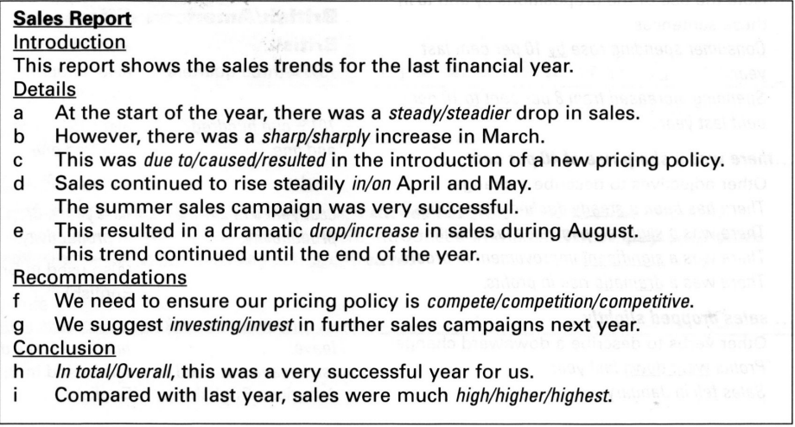

**Activity 4: Put in an appropriate word or phrase from the box to complete the**

**following report. (15 minutes)**

| due | ~~purpose~~ | recommend | recommendation | visitors | placed |
| --- | --- | --- | --- | --- | --- |
| **1. Introduction**  The **purpose** of the report is to analyze success of our marketing in Brazil.    **2. Details**   1. 25 000 _ _ _ _ _ _ _ attended the Trade Fair in Sao Paolo. 2. 900 enquiries were taken. 3. 150 orders were _ _ _ _ _ _ _ _.   **3. Recommendations**   1. The main_ _ _ _ _ _ _ is to appoint new agents in Brazil. 2. We also_ _ _ _ _ _ _ opening an office in Sao Paolo. 3. We need to make a decision by the end of the month.   **4. Conclusion**  The increase in business was _ _ _ _ _ _ _ to our new marketing strategy. Brazil will be a key market for us in the future. |

**Activity 5: Find 6 verbs in the square which show an upward or downward**

**movement. (10 minutes)**

**Example:** decrease

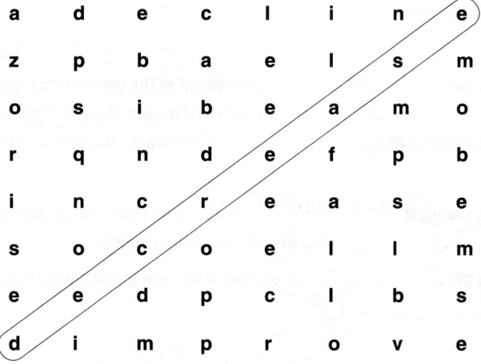

**Activity 6: Look at the graphs below, then use the phrases in the box to**

**complete the report. Each paragraph has been started for you. Decide which graph each paragraph describes. (10 minutes)**

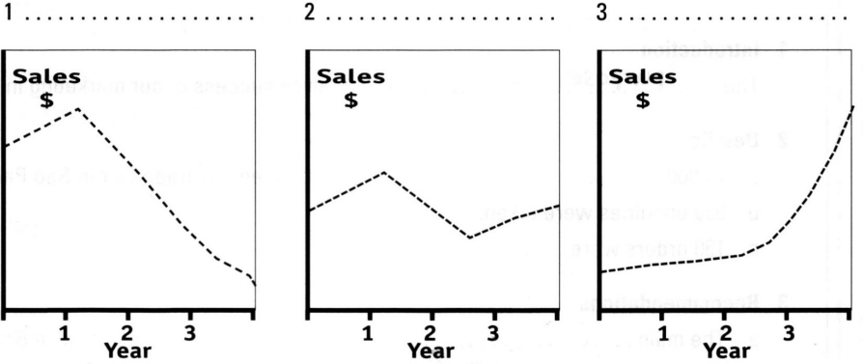



**Three years ago, we opened three new shops.**

**A**

Alpha performed well in the first year and sale **rose** significantly. However, a change of management in year two led to _ _ _ _ _ _ _ _ _ _ _ _ Fortunately, a new manager was appointed last year and there has been a steady _ _ _ _ _ _ _ _ _ _ _ _ since then.

**B**

In the first year BNK was **the least** successful of the three stores. Sales were _ _ _ _ _ _ _ _ _ _ _ _

and did not improve much in the second year. Then we redesigned the store and this has _ _ _ _ _ _ _ _ _ _ _ _ a significant increase in sales.

**C**

ln contrast, Geo was the most **successful** in year one. However, since then, sales have fallen _ _ _ _ _ _ _ _ _ _ _ _ increased competition locally. Sales are continuing to _ _ _ _ _ _ _ _ _ _ _ _ and we may have to consider closing the store.

**Activity 7:**

**Activity 8: Game - *Simon* Says: Follow teacher’s instruction. (20mns)**

**Activity 9: Reading Comprehension - giving instructions by email (30mns)**

**Activity 10: Group discussion - discuss this question in a group of 4. (15mns)**

**Activity 11: Write an email to your friend about giving instruction on looking after your laptop. This activity should be done inside the class. (30mns)**